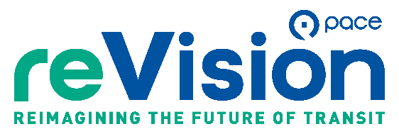

Promotional Toolkit
Please share the Draft ReVision Plan, survey, and public engagement opportunities.

What’s in this toolkit?
- Shareable social media posts (content and graphics)
- Sample newsletter and eblast text
- Survey, virtual open house, and pop-up event information
- Related links and resources

Why share this information with your networks?
ReVision is Pace’s proposed blueprint to make suburban bus service more frequent, connected, and accessible across the region. The plan calls for a 50 percent overall increase in service, including Pulse lines, fixed routes, and On Demand service.
Pace is asking riders, residents, municipalities, and community partners to review the draft network, complete the survey, and participate in upcoming engagement opportunities.
Please use the shareable content below to promote the Draft ReVision Plan, survey, virtual open house, and regional pop-up events. Thank you for helping Pace gather community feedback.

Related links and resources
- Draft ReVision Plan and survey: PaceBus.com/ReVision
- Regional pop-up events: PaceBus.com/popups
- Communications and graphic requests: communications@pacebus.com

Sample newsletter text (for websites, community newsletters, and eblasts)

Help Shape the Future of Suburban Bus Service
ReVision is Pace’s bold plan to deliver more frequent, connected, and accessible suburban bus service

Pace recently unveiled its Draft ReVision Plan, a bold proposal to transform suburban bus service across its six-county region for the way people travel today. The plan calls for a 50 percent overall increase in service across Pulse lines, fixed routes, and On Demand service, with more frequent, connected, and accessible options, particularly at night and on weekends. Every county in Pace’s service area would receive at least a 45 percent increase in service.
Pace has launched a broad public engagement effort to gather feedback on the draft network. Opportunities to participate include a public webinar, a survey, pop-up events, and online channels. Pace’s Field Team will also speak directly with riders across the region and encourage them to share their perspectives.
Riders, residents, and community partners can review the Draft ReVision Plan and complete the survey at PaceBus.com/ReVision, attend a virtual open house on November 18th from 6 p.m. – 7 p.m., or visit Pace at one of several pop-up events throughout the region from October 24th through November. A full list of events is available at PaceBus.com/popups.

Social media posts
Consider tagging Pace Suburban Bus on Facebook, X, Instagram, and LinkedIn so Pace can engage with and share your content. Pace can resize ReVision graphics for different platforms upon request. Email communications@pacebus.com.

Sample post 1
Help shape the future of suburban bus service! ReVision is Pace’s bold proposal to reimagine the suburban bus system. Review the plan and complete the survey to share your feedback on a proposed network with more frequent, connected, and accessible service: PaceBus.com/ReVision.

Sample post 2
Talk transit with Pace! ReVision is a bold proposal to transform suburban bus service for the way people travel today. Attend a virtual open house on Nov. 18 from 6 – 7 p.m. or visit Pace at one of several pop-up events throughout the region. Learn more: PaceBus.com/ReVision.

Graphics
